Feature Engineering:

Feature Engineering is the process of using domain knowledge to extract features from row data. These features can be used to improve the performance of machine learning algorithm

2. Feature Construction:

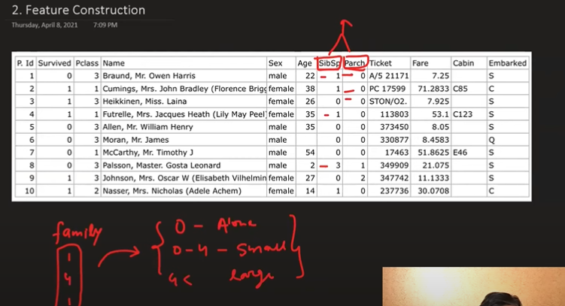

3.Feature Selection :  
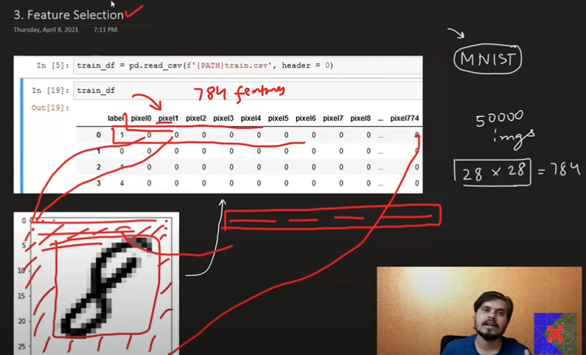

4.Feature Extraction:

